

<Date>

<Member Name>

<Member Address>

<City, State, Zip>

Nyob Zoo Txog <Member Name>:

Tam li ib tug tswv cuab ntawm UCare’s Connect + Medicare (HMO SNP), koj tau txais ib tus neeg lis hauj lwm saib xyuas. Kuv yuav yog koj tus neeg lis hauj lwm saib xyuas tshiab txij li <date> . Kuv yuav hu koj sai-sai no kom pom tias koj nyob li cas lawm thiab txiav txim siab koj cov kev xav tau.

Yog koj muaj lus nug thov hu rau kuv ntawm <phone number>. Yog koj hu tau kuv ua suab, thov kaw suab cia thiab koj tus xov tooj. Yog tias koj yog ib tug hnov lus tsis zoo, thov hu rau Minnesota Relay ntawm 711 los sis 1-877-627-3848 (qhov kev pab cuam hais lus ntawm ncauj rau ncauj).

Kuv tos ntsoov yuav los nrog koj tham sai-sai no. Hmov tshua txog,

<Care Coordinator Name>

<Care Coordinator Job Title>

<County or Agency Name>

<Phone Number>

<E-mail Address>

UCare Connect + Medicare (HMO SNP) yog ib lub phiaj xwm kev noj qab haus huv muaj ntawv cog lus ua hauj lwm nrog tag nrho ob lub khoos kas Medicare thiab lub Minnesota Medical Assistance (Medicaid) los muab cov txiaj ntsig rau tag nrho ob lub khoos kas cov neeg tso npe. Kev tso npe nyob rau UCare Connect+ Medicare nws nce raws lis kev rov tsim daim ntawv cog lus dua.

MSC+ SNBC H2456 H5937_010517 DHS Approved (01252017) U14011D Hmong (U2857D) (11/18)

500 Stinson Blvd NE, Minneapolis, MN 55413 | 612-676-6500 | fev 612-676-6501 | **ucare.org**

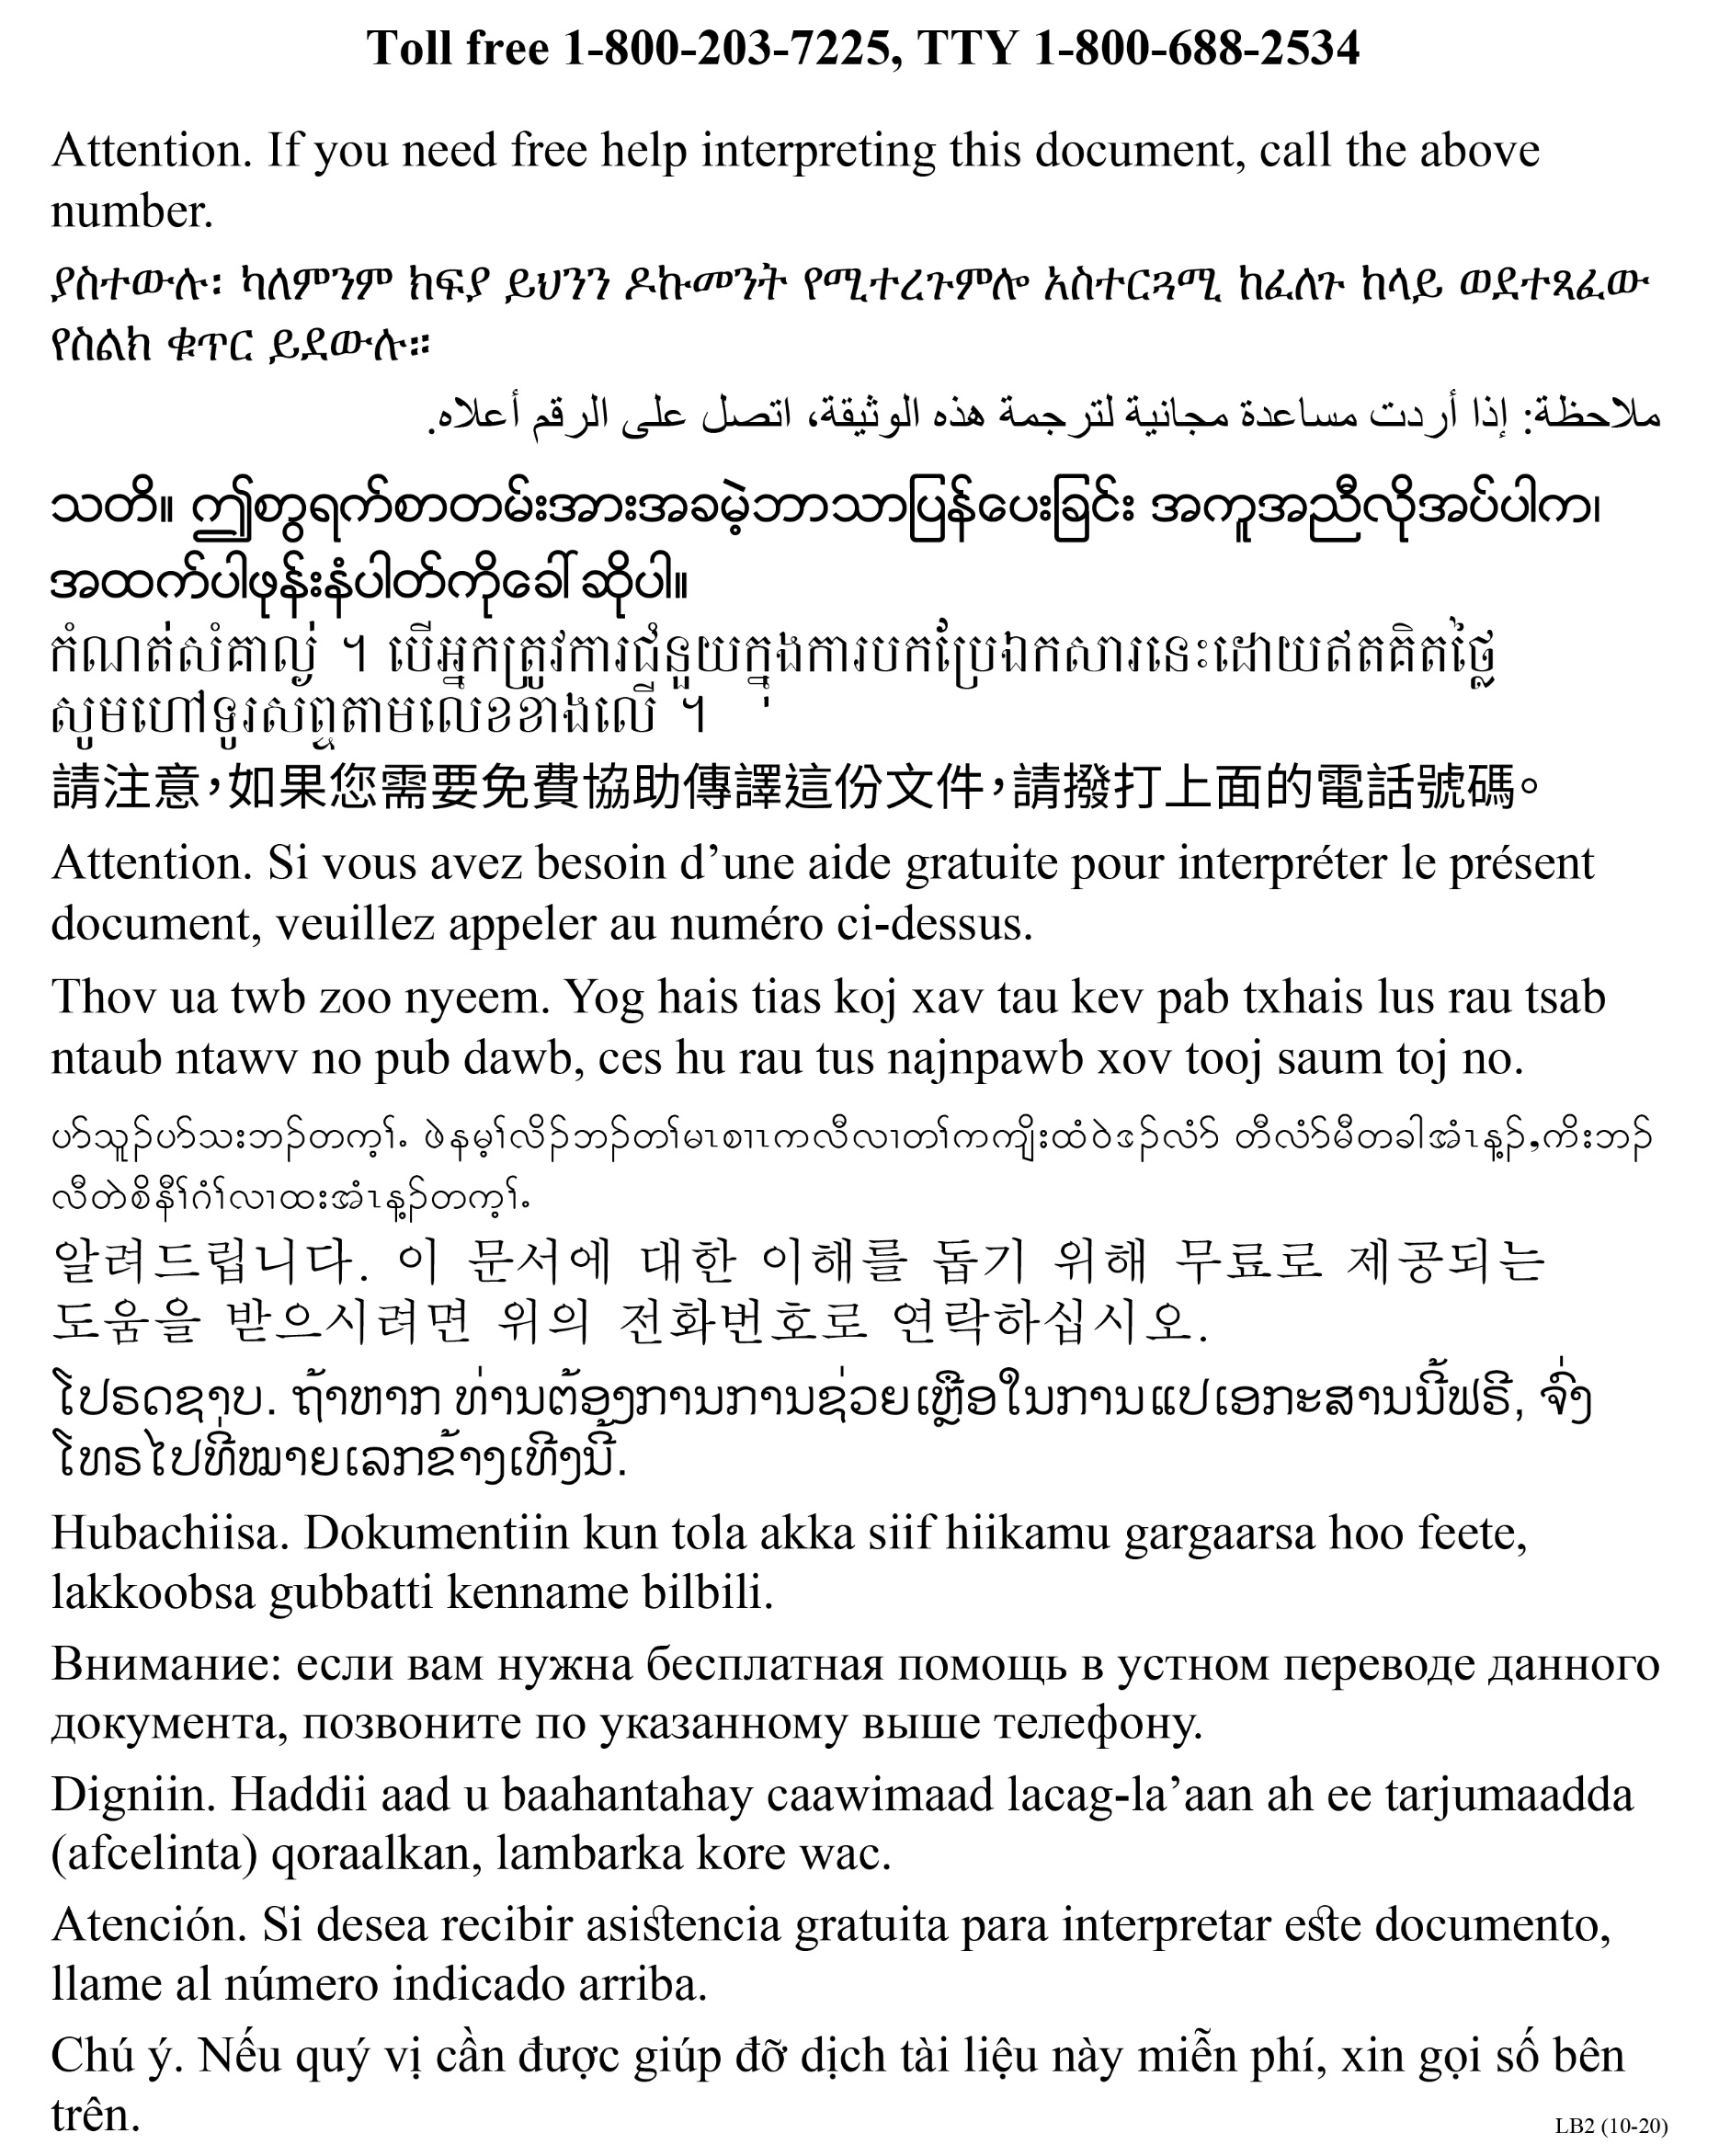

DHS_Tau Hloov Kho_ll/24/2021