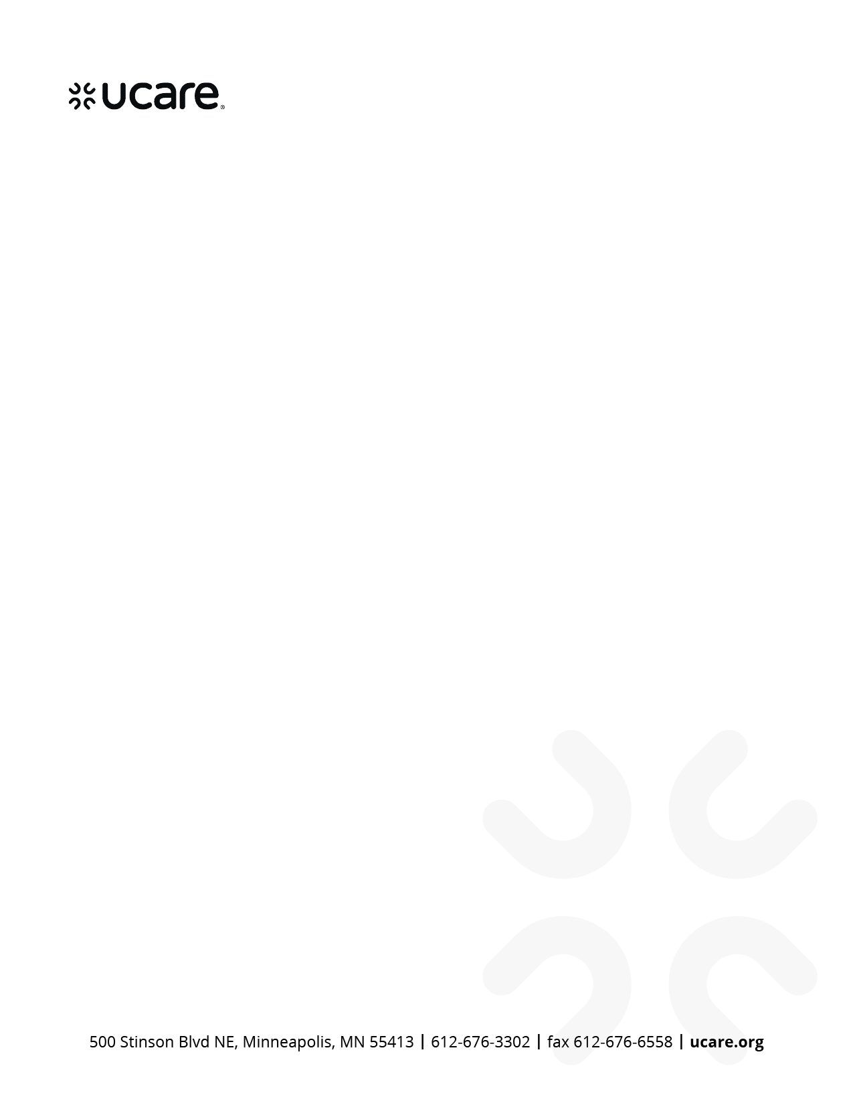

Date

<Member Name>

<Member Address>

<City, State ZIP>

Kabajamoo Member Name,

UCare tti fayyummaa kee fooyyessuf kutannoo qabna. Karoorri deeggarsa si waliin gaafa Date qophaa'e kana wajjin ergamee jira. Maaloo, Karoora Deeggarsaa kana sirriitti ilaali.

**Akka yaadachiisatti, yeeroo beellama kee sana wantoota kanneen irratti mariyannee turrre:**

* Karaalee ittiin fayyaa qaamafi sammuu kee eegamu
* Fayyummaa kee eegufi fooyyessuf waldhaansa fayyaa fayyadamuu
* Fedhiiwwan waldhaansa ittisaa kee
* Topic(s) discussed at visit

**Kanneen armaan gadii yoo taate, care coordinator (qindeessaa waldhaansaa) kee qunnamuu hin dagatin:**

* Yoo hospitaala ciifte ykn ciisuf karoora qabaatte
* Yoo kufte
* Fayyaa qaamafi sammuu keerratti jijjiirama yoo argite
* Deeggarsa ykn tajaajilawwan argachuurratti gargaarsa yoo barbaadde

Gaaffii yoo qabaatte ykn Karoora Deeggarsaa wajjin walii hin galtu yoo ta'e, Phone Number irratti naaf bilbili. Fedhiiwwan kee yoo jijjiiramanis bilbiluu dandeessa. Fayyadamtoonni TTY, 711 ykn 1-877-627-3848 irratti Minnesota Relay dhaaf bilbilaa (tajaajila bilbilaa qaama miidhamaan akka bilbilu gargaaru (speech-to-speech relay service)).

Nagaa wajjin,

<Care Coordinator Name>

<Care Coordinator Job Title>

<County or Agency Name>

<Phone Number>

<Email Address>

H5937_H2456_6336_072022 accepted

U14265 Oromo (U6336) (06/2024)

